FAST, FASTER, FASTEST!
DUC TAKES THREE OF TOP SIX AT HEAD OF THE OKLAHOMA

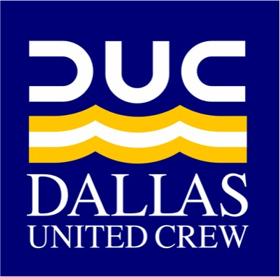
Dallas United Crew’s (DUC) youth team dominated at the Head of the Oklahoma Regatta, racing against crews from Texas, Utah, Oklahoma, Colorado, and Kansas. in a 4,000-meter course long the Oklahoma River. In the fall, rowing returns to grand-prix-style racing, dubbed “head races”. Staggered starts, passing, and a race against the clock build the excitement as crews traverse the curving, 4000-meter course, threading the piers of nine bridges to reach the 2000-meter straightaway.

Fast, Faster, Fastest! DUC’s powerhouse Men’s Varsity 8+ crew took gold in the 4,000-meter race beating regional rivals, Jesuit Prep, with a convincing ten-second lead. DUC’s Nationally ranked (#8) Under 17 (U17) men overpowered OKC Riversport’s and Waterford’s varsity men to claim the bronze, and DUC’s third varsity boat book-ended the race, besting all rivals’ second varsity boats.

“We were very proud of all of our DUC performances today. It was a terrific opening to the new season,” exclaims DUC Head Coach, Steve Perry.

DUC’s Varsity Women’s 4+ earned a top 10 ranking at Youth Nationals in June, and with four rowers returning, they earned the top seed for the Women’s 8+ at Head of the Oklahoma. On the last turn before the straightaway, DUC’s boat got the inside curve and were ready to bolt to the finish, but a submerged wire sheared the skeg from the hull and with it the crew’s steering.

Saturday ’s events culminated in the exciting 500-meter OG&E Night Sprints, head-to-head races that captivate the crowds as crews fly down the course in less than 90 seconds. Borrowing a boat from their teammates, the DUC Women’s varsity 8+ put the afternoon’s disappointments behind them with a crushing victory with a deck-to-bow lead over the pack, earning gold.

Fortunes flipped as the DUC Men’s boats gathered for the 500-meter start. Wind accompanying an isolated rain-shower blew DUC’s first varsity boat into the shore as they accelerated to top speed, and once again obstacles beneath the surface tangled a DUC crew. Too damaged to race, they scratched, leaving DUC’s U17 boat to face Jesuit’s top crew. Light, but mighty, they held the rangers to a 6-seat lead, earning silver.

Next on the fall regatta schedule for DUC is the Head of the Charles in Boston, the largest international regatta in the world. DUC will send its largest contingent ever with five boats entered.

With 22 USRowing Regional Titles, DUC is Texas’s largest sweep rowing team. Eights and Fours decide NCAA and IRA collegiate rowing championships, and DUC is dedicated to preparing athletes who want to row in college for the challenge. With sixty collegiate varsity recruits since 2012, DUC is proven in it’s ability to open college doors. High schoolers are invited to a one-week rowing trial. Visit DallasUnitedCrew.org or email info@DallasUnitedCrew.org for details.

Women’s Varsity 8+ : Gold (500-meter)
Ellie Rodriguez, Olivia Till, Sierra Ross, Caroline Payseur, Lauren O'Grady, Abby Fowler, Zeynap Akdora, Nora Thompson, Lucy Roberts (Cox)

Men’s Varsity 8+ : Gold (4,000-meter)
Archer Smith, Luke Schweizer, Peyton Lewis, Sam Tharp, Jack Haney, Landon Tinker, Clark Hobbs, Cole Farley, Kaila Galliford (Cox)

Men’s U17 8+ : Silver (500-meter), Bronze (4,000-meter)
Matthew Slear, Nate McNeill, Daniel Sneed, Logan Betts, Jack Martin, Luke Blankenship, Jack Craycroft, Jack Stotts, Jeff Kang (Cox)

