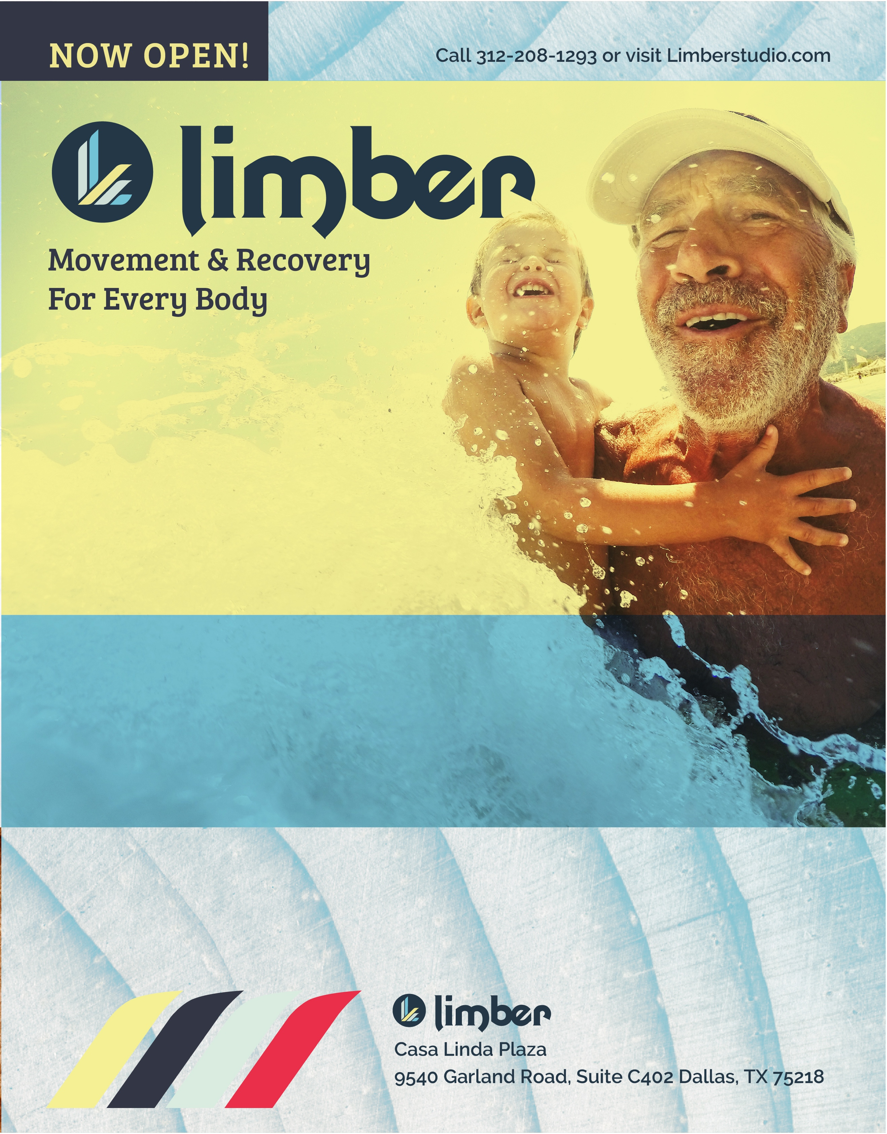

***Ribbon Cutting Event***

* Saturday, January 19th
* 1-2 p.m.
* Catered by Dallas Grilled Cheese Co.

***“It’s not working out, it’s working in”***

Our approachable, achievable fitness programs are a great place to start. We’re here to guide you through whatever stage of fitness you’ve reached to achieve your best performance. Let’s get moving!

It’s easy! Just visit Limberstudio.com and sign up for a FREE Guest Membership. **You’ll automatically receive two free classes, with any class combination you want.** We can’t wait to welcome you to our new studio…let’s get moving today!

Ready to reclaim a better quality of life and health?

**WELCOME OFFER:**

First two sessions **FREE**